1. Agenda:
   1. Running application to confirm if the configurations we made in last two lectures working fine.
2. 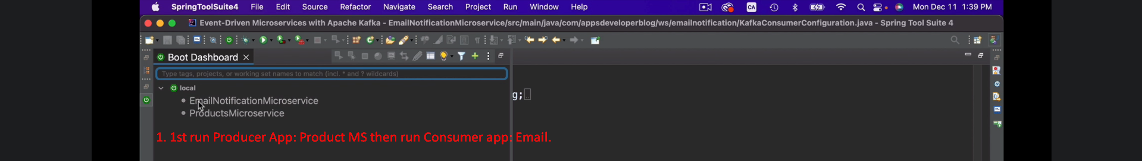
3. 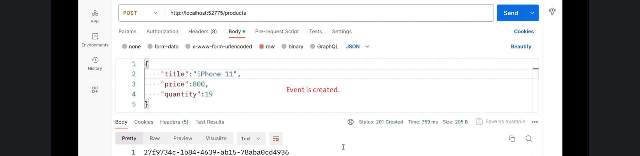
4. 